Analytical Data Sheet

Product Name:  Cas:  Formula:  Molecular Weight: | Fmoc-N-Me-Thr(Bzl)-OH  198561-81-8  C₂₇H₂₇NO₅  445.5 | Catalog #:  Lot No.:  Prolonged storage:  Manufacturing Date: | C00079  I0207013  2-8 ℃  May.11th.2017

Tests | Specifications | Result
Appearance:  Mass Spectrum  ¹H NMR:  Purity(HPLC)  Assay:  TLC:  Solubility  Residual solvent: | White to off White powder  In accordance with the standard  In accordance with the standard  ≥98%  97%~102%  ≥98%  1mmol in 2ml DMF clear soluble  ≤2% | White powder  Complies  Complies  99.30%  98.66%  100%  1mmol in 2ml DMF clear soluble  0.38%
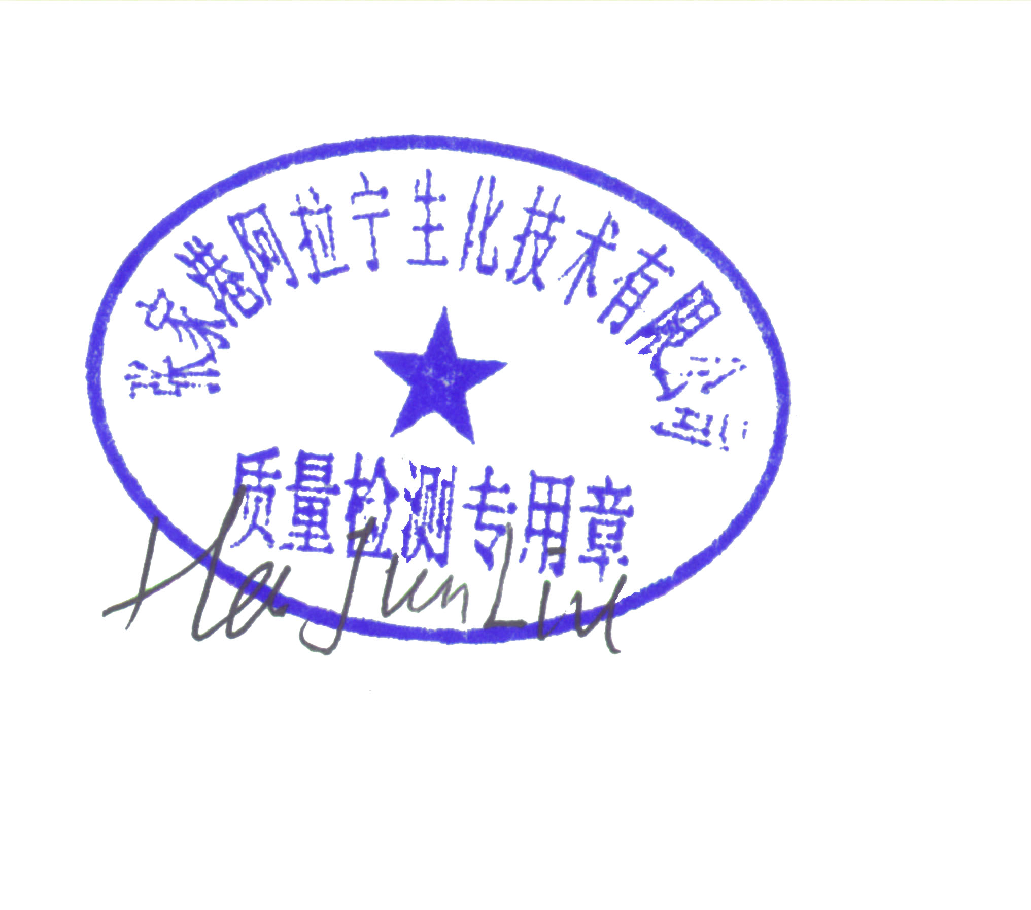

Remarks: Not for Human Use. Research Purposes Only.
刘华军 May.12th.2017
Release By: Date:

Alabiochem Techniqu e Company Add：No.1, North of GuoTai Road, Zhang Jia Gang city ,SuZhou, P.R.China
Fax: 0086-512-56727736 sales@Alabiochem.com www. Alabiochem.com

